Joe's Video Store — The Full Walkthrough
View 1 → View 2 → Merge → Final ERD

The Overall Roadmap

JOE'S VIDEO STORE DATABASE

VIEW 1
Customer Rents Video
|
0NF -> 1NF -> 2NF -> 3NF
|
VIEW 1 ERD
|
------------------------
|
VIEW 2
Video Information
|
0NF -> 1NF -> 2NF -> 3NF
|
VIEW 2 ERD
|
------------------------
|
MERGE THE VIEWS
|
FINAL DATABASE ERD

Part 1 — View 1: Customer Rents Video

Normalization Exercise: Joe’s Video Store - View 1

Joe wants you to develop a small database application to help him run his video rental store.
Tracking information to rent a video is one system requirement.
You are to develop a view schema in 3NF for the Customer Rents Video view.
A sample screen layout is shown below:

Joe’s Video Store: Video Rentals
Transaction ID: 1 | Date: May 18, 2006

Customer ID: 12345 | Name: Mira Washington
Phone: 962-6190 | Address:
  76 Pacific Ave
  My Town, Alberta
  T3J 2X0

Video ID | Copy  Number | Title | Return  Date | Rental Charge
Hor-1 | 1 | Carrie | May 21, 2006 | 3.00
Hor-2 | 3 | The Exorcist | May 21, 2006 | 3.00
Rom-1 | 1 | As Good As It Gets | May 19, 2006 | 5.00
 |  |  | Subtotal: | 11.00
 |  |  | GST: | 0.77
 |  |  | Total: | 11.77

Business Rules:

- A customer may have a maximum of ten videos rented simultaneously.
- Joe knows the rental charges change over time, so he wants the system to record the rental charge for each video on a transaction (historical information) as well as record the current rental charge for each video.
- Transaction ID, Customer ID and Video ID are unique.
- Copy Number is unique within Video ID (the first copy of any given video is copy number 1).

You are to produce a view schema in 3NF. Show the schema in ERD notation. Document any assumptions you make. Attributes:
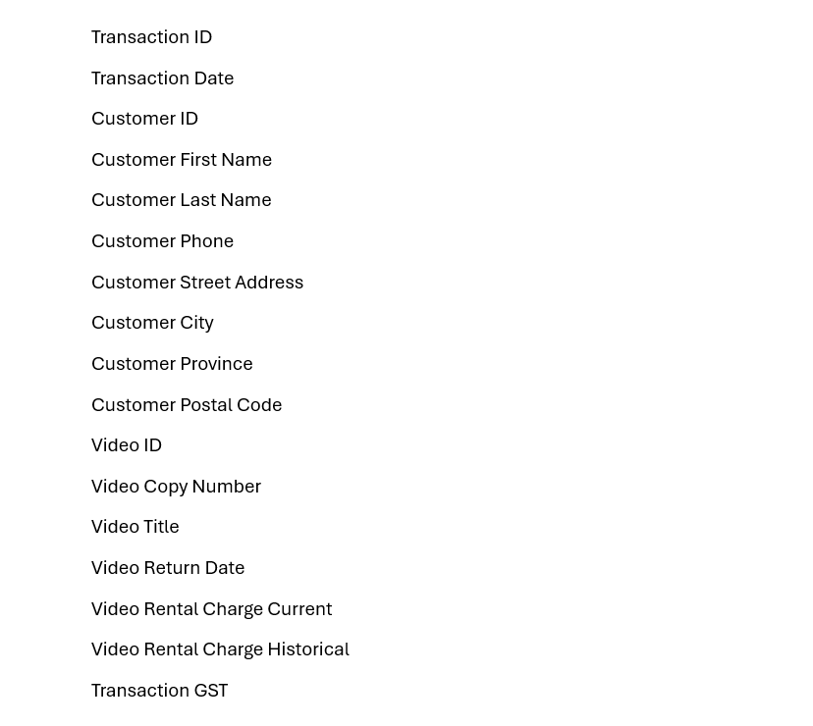

The supplied View 1 scenario is the Customer Rents Video view. The source gives us Transaction ID, customer information, video information, and multiple rented videos on a transaction. It also gives the important business rules about historical rental charges and the uniqueness of Transaction ID, Customer ID, Video ID, and Copy Number within Video ID.
Step 1 — Read the Business Rules First
Don't open the spreadsheet yet.
Identify:
Entities hiding in the screen
- Customer
- Transaction
- Video
- Video Copy
"Which one can repeat?"
→ The answer is the videos on a transaction. One transaction can contain multiple rented videos. So we already know we're going to have a repeating group.
JOES VIDEO STORE VIEW 1
Initial Table
TransactionID, TransactionDate, CustomerID, Name, Phone, Address, (VideoID, CopyNumber, Title, ReturnDate, RentalCharge, HistoricalRentalCharge), SubTotal, GST, Total

1NF
TransactionID, TransactionDate, CustomerID, FirstName, LastName, Phone, Address, City, Prov, PC, SubTotal, GST, Total

VideoID, CopyNumber, Title, ReturnDate, RentalCharge, HistoricalRentalCharge, TransactionID

2NF
TransactionID, TransactionDate, CustomerID, FirstName, LastName, Phone, Address, City, Prov, PC, SubTotal, GST, Total

VideoID, CopyNumber, ReturnDate, HistoricalRentalCharge, TransactionID

VideoID, Title, RentalCharge

**Rental charge is the same for all rentals of that movie (we do not charge differently for longer rentals)

3NF
TransactionID, TransactionDate, SubTotal, GST, Total, CustomerID

CustomerID, FirstName, LastName, Phone, Address, City, Prov, PC

VideoID, CopyNumber, ReturnDate, HistoricalRentalCharge, TransactionID

VideoID, Title, RentalCharge

Step 2 — Build the 0NF / Initial Table
old notation.
The official solution starts with:
TransactionID,
TransactionDate,
CustomerID,
Name,
Phone,
Address,
(
VideoID,
CopyNumber,
Title,
ReturnDate,
RentalCharge,
HistoricalRentalCharge
),
SubTotal,
GST,
Total
"The parentheses are the most important thing you're looking for in 0NF. Parentheses mean: this group can repeat."
So visually:
TRANSACTION
|
+-- TransactionID
+-- TransactionDate
+-- CustomerID
+-- Customer information
|
+-- (VIDEO INFORMATION)
+-- VideoID
+-- CopyNumber
+-- Title
+-- ReturnDate
+-- RentalCharge
+-- HistoricalRentalCharge
Then translate that back into the spreadsheet.
Step 3 — 1NF
"What violates 1NF?"
Two things:
Violation 1: repeating group
(VideoID, CopyNumber, Title,
ReturnDate, RentalCharge,
HistoricalRentalCharge)
Violation 2: composite attributes
The solution breaks:
Name
into:
FirstName
LastName
and:
Address
into:
Street Address
City
Province
Postal Code
The supplied 1NF solution does exactly this.
Step 4 — Move the Repeating Group
This is where students often get lost in the old worksheet.
"We're not randomly moving columns. We're creating a child entity because one transaction can contain many videos."
Then show:
TRANSACTION 1 --------- M TRANSACTION DETAIL
Now translate it into their required format.
Transaction
TransactionID PK
TransactionDate
CustomerID
FirstName
LastName
Phone
Address
City
Province
PostalCode
SubTotal
GST
Total
Transaction Detail
TransactionID
VideoID
CopyNumber
Title
ReturnDate
RentalCharge
HistoricalRentalCharge
The solution represents the detail table with Transaction ID carried into the new entity as part of its key.
Step 5 — Explain the Composite Key
"Can TransactionID uniquely identify a row in Transaction Detail?"
→ No. One transaction has multiple videos.
"Can VideoID uniquely identify a row?"
→ No. A video can appear in multiple transactions.
"What identifies one rental line?"
→ The combination of: TransactionID + VideoID + CopyNumber
old-format worksheet:
"This is why you see multiple attributes becoming PK. The spreadsheet is showing you the composite key."
Step 6 — 2NF
"We ONLY look for partial dependencies in tables with composite primary keys."
This immediately narrows the search.
Transaction has: TransactionID — single PK. So: No 2NF violation.
Transaction Detail has a composite key. So now we inspect it.
The important question: Does Title depend on the entire TransactionID + VideoID + CopyNumber?
→ No. Title depends on VideoID. Same with current Rental Charge.
So we move:
VideoID -> Title
VideoID -> RentalCharge
into:
VIDEO
VideoID PK
Title
RentalCharge
The supplied View 1 solution explicitly makes this move and notes that the rental charge is the same for all rentals of that movie.
Step 7 — Show the 2NF Result
three entities:
TRANSACTION
TransactionID PK
TransactionDate
CustomerID
FirstName
LastName
Phone
Address
City
Province
PostalCode
SubTotal
GST
Total
TRANSACTION DETAIL
TransactionID PK/FK
VideoID PK/FK
CopyNumber
ReturnDate
HistoricalRentalCharge
VIDEO
VideoID PK
Title
RentalCharge
"This is what the spreadsheet is trying to show you. The arrows aren't the database. They are showing the reasoning that produced these three entities."
Step 8 — 3NF
"Do we have any non-key attribute depending on another non-key attribute?"
Look at Transaction. We have:
TransactionID -> CustomerID
CustomerID -> CustomerName
CustomerID -> Phone
CustomerID -> Address
So customer information doesn't belong in Transaction. Therefore:
CUSTOMER
CustomerID PK
FirstName
LastName
Phone
StreetAddress
City
Province
PostalCode
And Transaction becomes:
TRANSACTION
TransactionID PK
TransactionDate
CustomerID FK
SubTotal
GST
Total
This matches the supplied 3NF solution.
Step 9 — View 1 ERD

CUSTOMER
|
| 1:M
v
TRANSACTION
|
| 1:M
v
TRANSACTION DETAIL
|
| M:1
v
VIDEO
"Now we're going back to the assignment and putting this into its required ERD notation."
The supplied View 1 ERD contains Customer, Transaction, Video, and Transaction Detail, with PK/FK notation.
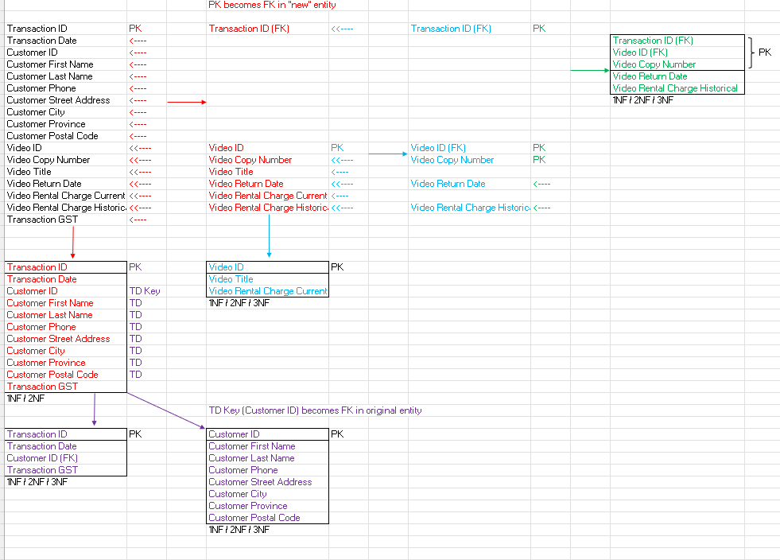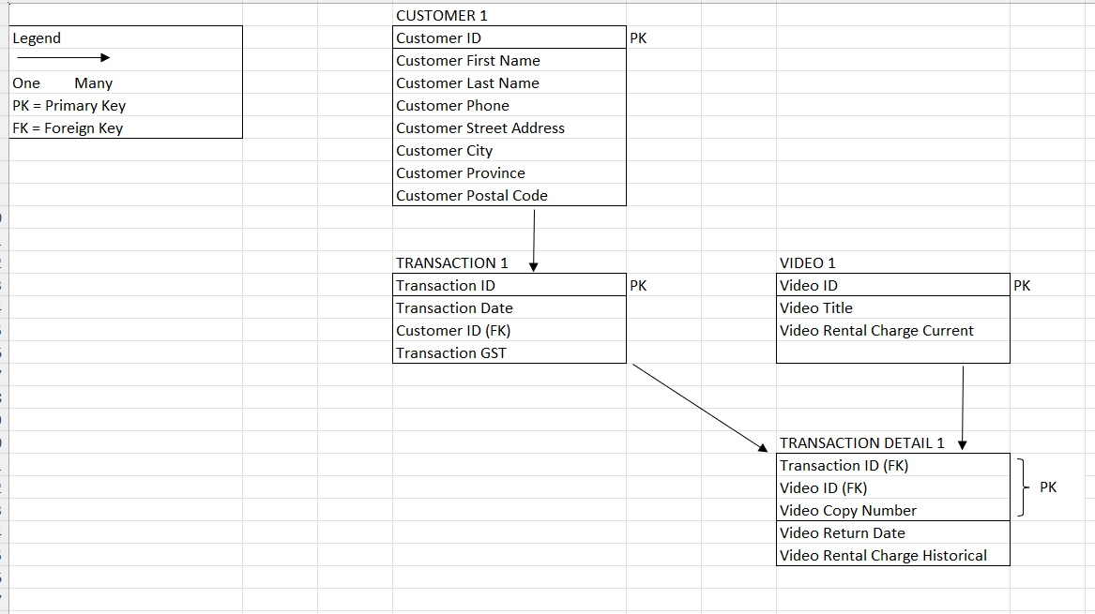
Part 2 — View 2: Video Information
"View 1 started with a transaction. View 2 starts with the video inventory itself."

Normalization Exercise: Joe’s Video Store - View 2

Joe wants you to develop a small database application to help him run his video rental store. Tracking video information is one system requirement.

You are to develop a view schema, in 3NF for the Video information view.

A sample screen layout is shown below:

Joe’s Video Store: Video Information
Video Id: Hor-1 | Title: Carrie

Type Id: 1 | Type Name: Horror Movie
Total no of copies: 5 | No of copies available for rental: 2
Format: VHS  Cost: $9.00 | Rental Charge: $3.00  Rating Code: R  Rating Description: Restricted Adult

Copy  Number | Available for  rental
1 | no
2 | no
3 | Yes
4 | Yes
5 | no

Business Rules:

- Movie Types are: Horror, Comedy, Action, Romance, Science fiction,..
- Formats are: VHS, VCD, DVD.
- Movie Ratings are: Children, Youth, Adult, Restricted Adult, and X-Rated
- Copy Number is unique within Video Id (the first copy of any given video is copy number 1).

You are to produce a view schema in 3NF. Document any assumptions you make.
Merge this user view with the Video rentals user view.

The View 2 source contains Video ID, title, type, format, rental charge, cost, rating, and a repeating group for copies.
Step 10 — View 2 Initial Table
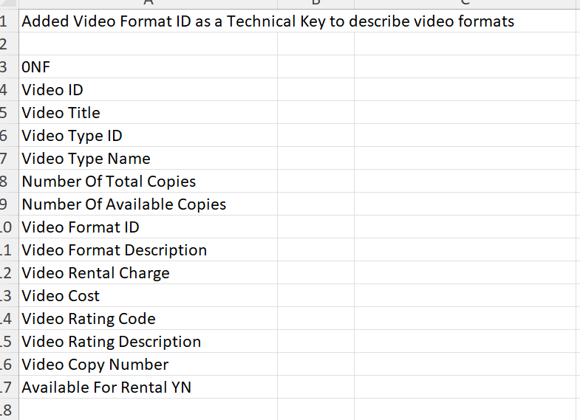
JOES VIDEO STORE VIEW 2
Initial Table
VideoID, Title, TypeID, TypeName, NumberOfCopies, NumberOfAvailableCopies, Format, RentalCharge, Cost, RatingCode, RatingDescription,(CopyNumber, AvailableForRental)

1NF
VideoID, Title, TypeID, TypeName, NumberOfCopies, NumberOfAvailableCopies, Format, RentalCharge, Cost, RatingCode, RatingDescription

VideoID , CopyNumber, AvailableForRental

2NF – No Violation
VideoID, Title, TypeID, TypeName, NumberOfCopies, NumberOfAvailableCopies, Format, RentalCharge, Cost, RatingCode, RatingDescription

VideoID , CopyNumber, AvailableForRental

3NF
VideoID, Title, TypeID, NumberOfCopies, NumberOfAvailableCopies, FormatID, RentalCharge, Cost, RatingCode

TypeID, TypeName

RatingCode, RatingDescription

VideoID , CopyNumber, AvailableForRental

**Since we have a predefined list of Formats (VHS, DVD, etc…) this attribute is of a similar type as TypeName and RatingDescription. The only difference being that there is no FormatID shown on the view. A technical key of FormatID should be added to identify Format and then it would create another key in 3NF.

FormatID, FormatDescription

The official format is:
VideoID,
Title,
TypeID,
TypeName,
NumberOfCopies,
NumberOfAvailableCopies,
Format,
RentalCharge,
Cost,
RatingCode,
RatingDescription,
(
CopyNumber,
AvailableForRental
)
Again: Parentheses = repeating group.
So:
VIDEO
|
+-- VideoID
+-- Title
+-- Type
+-- Format
+-- Rental information
+-- Rating
|
+-- (COPY)
+-- CopyNumber
+-- AvailableForRental
Step 11 — View 2: 1NF
The repeating group becomes:
VIDEO COPY
VideoID
CopyNumber
AvailableForRental
And VideoID is copied from the parent into the new entity.
The official solution shows exactly this transformation.
"What is the key of Video Copy?"
→ Neither VideoID nor CopyNumber alone is enough. So: VideoID + CopyNumber is the composite key.
Step 12 — View 2: 2NF
This is a beautiful example because the official answer is:
2NF — No Violation.
Why? Because:
VideoID + CopyNumber -> AvailableForRental
You need the whole key to identify the particular copy. So nothing is partially dependent.
"Not every table with a composite key automatically has a 2NF violation. You have to test the dependencies."
Step 13 — View 2: 3NF
Now look at:
VideoID -> TypeID -> TypeName
Therefore TypeName moves to:
VIDEO TYPE
TypeID PK
TypeName
Then:
RatingCode -> RatingDescription
becomes:
VIDEO RATING
RatingCode PK
RatingDescription
The course solution makes an additional modeling decision: Format gets a technical FormatID, because Format is treated similarly to the other predefined lookup values. The supplied solution explicitly documents that assumption.
So:
VIDEO FORMAT
FormatID PK
FormatDescription
Then Video contains the FKs.
Step 14 — View 2 Final Schema
VIDEO
VideoID PK
Title
VideoTypeID FK
NumberOfCopies
NumberOfAvailableCopies
FormatID FK
RentalCharge
Cost
RatingCode FK
VIDEO COPY
VideoID PK/FK
CopyNumber PK
AvailableForRental
VIDEO TYPE
VideoTypeID PK
VideoTypeName
VIDEO FORMAT
FormatID PK
FormatDescription
VIDEO RATING
RatingCode PK
RatingDescription
This corresponds to the supplied View 2 solution and ERD.
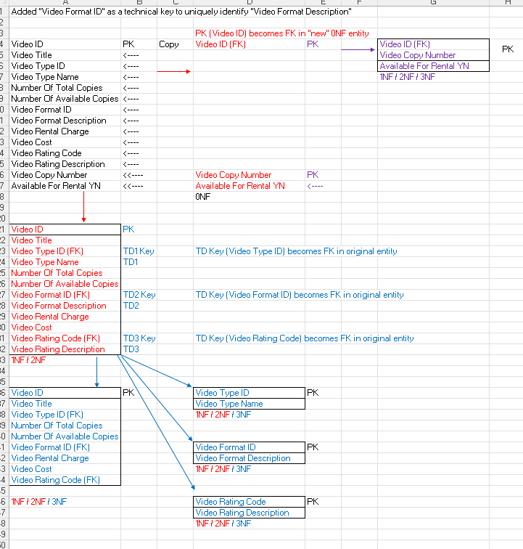
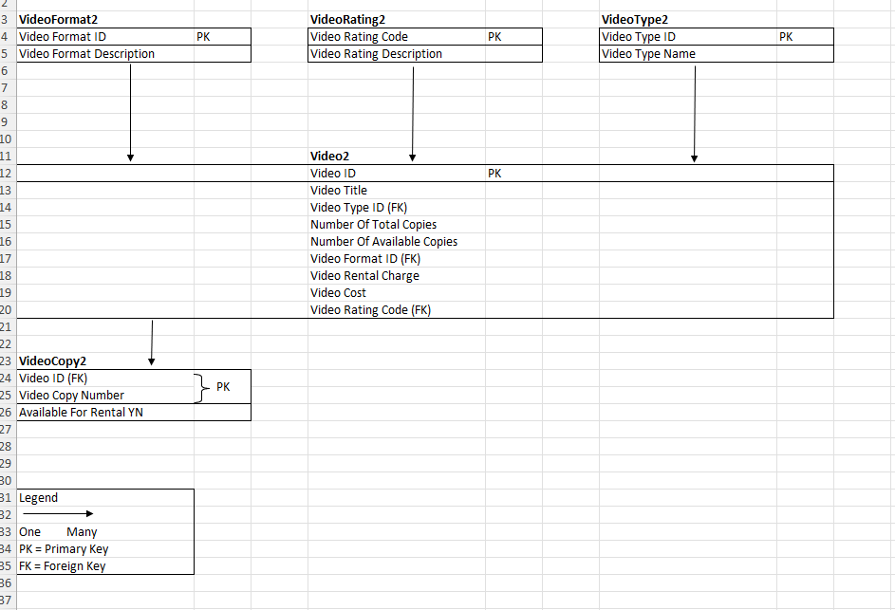
Part 3 — Now Merge
"We did NOT design these two views independently because we want two separate Video tables. We designed each view separately because each view represents a different perspective of the same system."
Now put this on the screen:
VIEW 1 | VIEW 2
CUSTOMER | VIDEO
TRANSACTION | VIDEO COPY
TRANSACTION DETAIL | VIDEO TYPE
VIDEO | VIDEO FORMAT
 | VIDEO RATING

"Do we have VIDEO twice?"
→ Yes.
"Do they represent the same entity?"
→ Yes.
"Do they have the same primary key?"
→ Yes: VideoID. Therefore: MERGE THEM.
The supplied merging worksheet explicitly states: “Merge Video1 and Video2 into Video because they have the same Primary Key.”
Step 15 — Merge the Two VIDEO Tables
View 1:
VIDEO
VideoID PK
VideoTitle
VideoRentalChargeCurrent
View 2:
VIDEO
VideoID PK
VideoTitle
VideoTypeID FK
NumberOfTotalCopies
NumberOfAvailableCopies
FormatID FK
VideoRentalCharge
VideoCost
RatingCode FK
Merge into:
VIDEO
VideoID PK
VideoTitle
VideoTypeID FK
NumberOfTotalCopies
NumberOfAvailableCopies
FormatID FK
VideoRentalChargeCurrent
VideoCost
RatingCode FK
The supplied merge solution shows this merged VIDEO entity.
Step 16 — Resolve the Rental-Charge Issue
View 1 has: Historical Rental Charge — because the charge at the time of the transaction must be preserved.
View 2 has: Current Rental Charge — because the current price can change.

VIDEO
+-- Current Rental Charge

TRANSACTION DETAIL
+-- Historical Rental Charge
That's not duplicate information. They're two different facts with two different meanings.
Step 17 — Final Merged Structure
MERGED 3NF ERD

